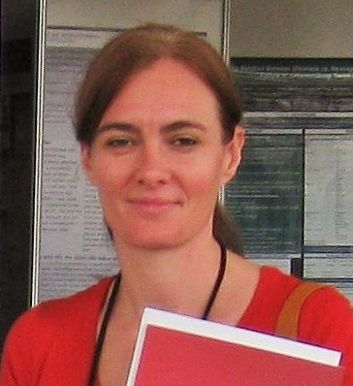
Mrs Friederike Baasner-Weihs (MPhil, MEcon)
Research Associate: HIV and AIDS Research Unit
Qualifications: MPhil HIV/AIDS Management (Stellenbosch), Master equivalent in economics (Hagen University, Germany)
Operation days: Monday-Friday
Operation time: On appointment
Email: friederike.baasner-weihs@nmmu.ac.za/ baasnerweihs@gmail.com

