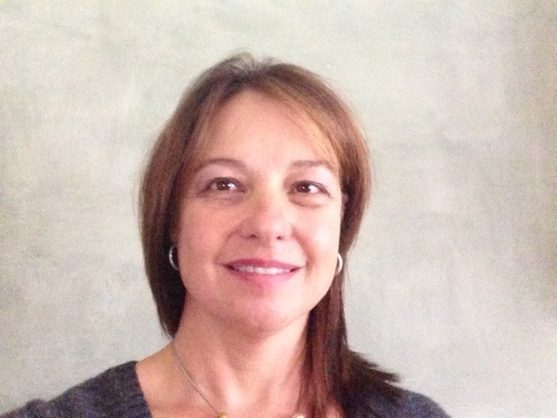
Dr Liana Steenkamp (Ph D Dietetics)
Research Associate: HIV and AIDS Research Unit
Qualifications: B Sc Dietetics (UFS); M Sc Dietetics (UFS), Ph D Dietetics (UFS)
Location: Summerstrand South Campus, 7th Building, Room 0115.
Contact: 041 504 2849
Fax: 0866899145
Operation days: Monday-Friday
Operation time: On appointment
Email: liana.steenkamp@nmmu.ac.za

