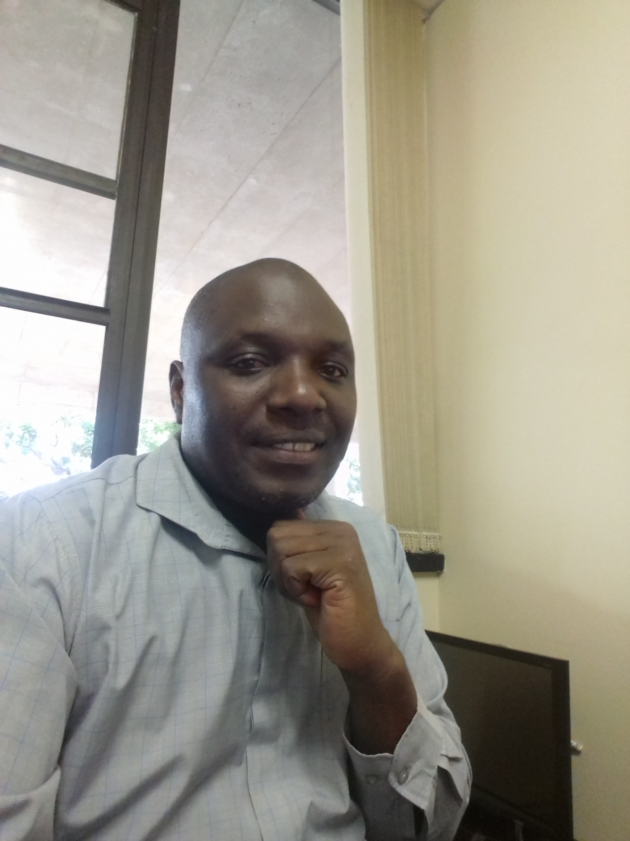
Mr KudaKwashe Muchena
Kudakwashe is a PhD candidate and a Research Assistant with the HIV and AIDS Research Unit. His research interests are in fatherhood, gender, personology and family relations. He is a qualitative researcher who specialize in Interpretative Phenomenological Analysis. He has published in an international journal.

